
Anatomy & Physiology Lesson 2 Exam
Please read these instructions before you begin to answer the questions that follow.
You are welcome to work your answers on this paper examination for your convenience. You will submit your final answers through an uploaded file through our app. When you are satisfied that your answers are correct, use the app to download an instruction file for the corresponding lesson. This will open the lesson, so you are able to add your work for grading. Complete this file upload for grading. Only the answers on the submitted file will be considered for grading.

You have reached the end of Lesson 2 and are ready for your Lesson 2 Examination. After you complete it, log in and submit through the app. Good luck!

Instructions:
Follow the instructions for each question. Show your work in the space provided and write the answer on the line. You will need to show your work on the file submitted to your teacher for grading.
Multiple Choice (worth 2 points each): Enter your selected answer into the blank space provided.

A. The first layer of defense against pathogens.1. Which of the following is NOT a function of bones?
  - The first layer of defense against pathogens.
  - Surrounds and supports delicate internal organs.
  - Site of hematopoiesis.
  - Participates in the release of energy from stored fat.

B. Phalanges, ulna, and humerus. 2. Which grouping below are examples of long bones?
  - tibia, femur, and vertebra
  - phalanges, ulna, and humerus
  - metacarpals, skull, and metatarsals
  - occipital, front, and temporal

D. Decrease in bone mass and strength. 3. What is a major concern astronauts have during extended space travel?
  - bone shortening due to the change in gravity
  - increase in bone density
  - reduced levels of hematopoiesis
  - decrease in bone mass and strength
C. Greenstick. 4. Which fracture type is more common in children and is classified as an incomplete
break?
  - comminuted
  - simple
  - greenstick
  - compound

A. Thoracic. 5. Which spinal region connects to the ribs?
  - thoracic
  - lumbar
  - sacral
  - cervical

C. Ulna. 6. Which bone is always on the “little finger side” of the forearm?
  - humerus
  - radius
  - ulna
  - tibia

D. All of the above. 7. Which of the following are functions of the articular cartilage?
  - Cushions the joint
  - Reduced wear to the joint
  - Reduces friction to the joint
  - All of the above

A. True. 8. True or False: People can be three quarters of an inch taller when they rise in the morning
  - True
  - False

C. Clavicle and scapula. 9. Collectively, which bones function as a sight of muscle attachment for many of the arm muscles? They allow for a wide range of motion in the arms.
  - xiphoid process and costal cartilage
  - manubrium and humerus
  - clavicle and scapula
  - none of the above

D. Osteoporosis. 10. Which bone disorder is associated with reduced bone strength and crush-type fractures of the vertebral column?
  - sprain
  - fracture
  - bursitis
  - osteoporosis

D. Both A and C. 11. Which muscle tissues are involuntary?
  - smooth muscle tissue
  - skeletal muscle tissue
  - cardiac muscle tissue
  - both A and C

_____12. A nerve that stimulates skeletal muscles is called a (n) A. motor neuron.
  - motor neuron
  - parallel nerve
  - axon terminal
  - sarcomere

A. Intercostals. 13. Which muscle aid in breathing by expanding the thoracic cavity during inhalation?
  - Intercostals
  - Diaphragm
  - Obliques
  - Trapezius

B. muscle that progressively becomes weaker. 14. Which of the following is associated with muscular dystrophy?
- protrusion of the abdominal cavity
- muscle that progressively becomes weaker
- weakened abdominal muscles
- both a and c

Use the figure below to answer questions 15-17.
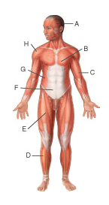
D. Bicep brachii.15. The structure labeled C above is the
  - temporalis.
  - tibialis anterior.
  - external oblique.
  - bicep brachii.

A.A. 16. Which structure is responsible for raising the eyebrows?
  - A
  - D
  - F
  - G

C. G and F. 17.Which labels correspond to muscles of the trunk?
  - H and A
  - C and B
  - G and F
  - F and B

B. Dehydration. 18. Which of the following may be a cause of cramps?
  - electrolyte imbalance
  - dehydration
  - deficiency in mineral such as calcium or potassium
  - all of the above

_____19. The ability of a muscle and other tissue to be stretched is the behavioral characteristic known as A. extensibility.
  - extensibility
  - elasticity
  - irritability
  - contractility

_____20. The fixed structure where a muscle attaches is the B. Origin.
  - insertion
  - origin
  - tendon
  - fixture

A. somatic nervous system. 21. Which nervous system controls skeletal muscle movement?
  - somatic nervous system
  - autonomic nervous system
  - parasympathetic nervous system
  - sympathetic nervous system

C. microglia. 22. Which glial cell absorbs and gets rid of dead cells and bacteria?
  - oligodendrocytes
  - ependymal
  - microglia
  - astrocytes

D. all of the above. 23. Some factors that can influence the speed of a nerve impulse are _______________.
  - body temperature
  - diameter of the axon
  - presence of myelin sheath
  - all of the above

A. reflex. 24. What is a rapid and involuntary response to a stimulus?
  - reflex
  - action potential
  - conduction
  - refractory period

D. dura mater, arachnoid mater, and pia mater. 25. What is the correct order of protective meninges from skull to brain?
  - arachnoid mater, pia mater, and dura mater
  - dura mater, pia mater and arachnoid mater
  - pia mater, dura mater, and arachnoid mater
  - dura mater, arachnoid mater, and pia mater

_____26. The B. gyru (is) are) the raised area of the brain
- sulcus
- gyrus
- white mater
- lobe

Use the image below to answer questions 27-30.
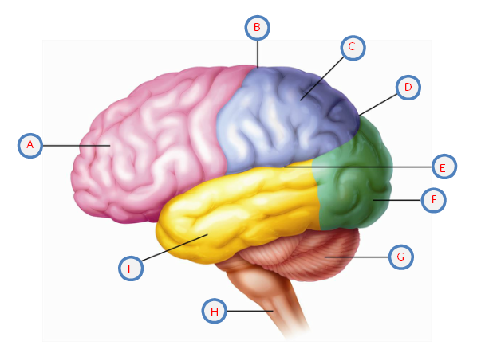
C. F. 27. Which structure above represents the occipital lobe?
  - A
  - D
  - F
  - I

A. A. 28. Which structure labeled above is responsible for behavior, intelligence, emotions, memory, and much more?
  - A
  - D
  - G
  - H

C. lateral sulcus. 29. The structure labeled E above is the ____________.
  - parieto-occipital sulcus
  - frontal lobe
  - lateral sulcus
  - cerebellum

A. motor impulses. 30. What is the function of the structure labeled G above?
  - motor impulses
  - breathing
  - hormone secreting
  - balance

Labeling (worth 14 points total) Use the diagram below to answer question 31.

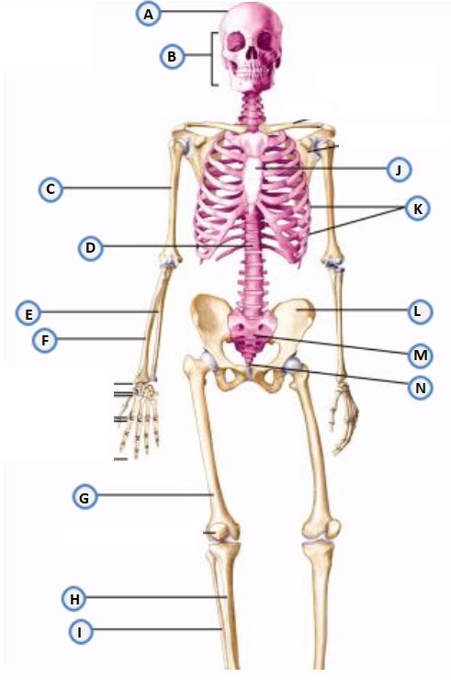
31. Use the following word bank to match the correct axial or appendicular skeleton part with the corresponding letter above.
Word Bank:
E. Ulna | K. Ribs | B. Facial Bones | ___ Scapula | D. Spine
H. Tibia | M. Sacrum | G. Femur | A. Cranium | J. Sternum
L. Coxal Bone | C. Humerus | I. Fibula | N. Coccyx | F. Radius

Matching (worth 10 points, 1 point each)
32. Match the terms in Column I with the descriptions in Column II.

Column I Column II

arthritis a. Joint inflammation associated with age
sprain b. low bone mineralization and strength
osteoporosis c. caused by running on hard surfaces or uphill
contusions d. balloon-like protrusions from the abdominal muscles
shin splints e. symptoms include motor function impairment
muscular dystrophy f. repeated seizures over time
hernia g. inflammation of the meninges
cerebral palsy h. overstretching of ligaments or tendons
meningitis i. bruise or bleed in the muscle
epilepsy j. progressive muscle weakness and muscle tissue loss

Essays (worth 16 points, 8 points each)
33. Imagine you are playing baseball and a line drive comes out of nowhere. You do not even realize till the last second that it is heading for your face! Explain the reflex type of movement you would experience. Describe the nervous system’s reaction from sensing the stimuli to response.
Startle reflex
In this condition, someone is likely to experience a Startle reflex. This is unconscious defensive response to a sudden stimuli. However, there are other reflexes that are likely to take place at the same time during the startle response. At first, the reflex occurs within the masseter muscle. This is followed by the reflex of the orbicularis oculi muscle which is the blinking of the eye. The head responds by showing the quickest move, and then the neck. The shoulders jerks and the legs show the response.

34. The movement of the muscles are divided into different planes or directional motions. Keep the movements of muscles in mind as you answer the questions below:
  - Imagine you are trying to write your name without using your thumb. Why is opposition important?
Opposition is the movement of the thumb that brings the tip of the thumb in contact with the tip of a finger. It's produced at the first carpometacarpal joint, which is a saddle joint formed between trapezium carpal bone and the first metacarpal bone. Opposition of the thumb is aides by the opponent pollicis muscle. The opposition of the thumb plays a vital role in hand functioning. Kinematically thumb opposition results from composite movements from multiple joints moving in multiple directions. Carpal tunnel syndrome impairs thumb opposition. The sensory and motor impairments resulting from the compressed and malfunctioning median nerve at the wrist leads to motor deficits in the abductor pollicis brevis, opponens pollicis and superficial belly of the flexor pollicis brevis. Prolonged compression of the median nerve potentially disturbs motor functioning of the thenar muscles, resulting into their atrophy. Atrophy of the opponens pollicis muscle thus results in impairment of thumb opposition. Carpal tunnel syndrome can be corrected by surgery to relieve the median nerve of the compression.

  - Flexion is movement in the sagittal plane. What areas of the body are affected by flexion? If all of these joints that perform flexion do so at the same time, what position are you in? Be sure to include a general description of flexion motion.
Flexion is the movement that decreases the angle between two body parts. Flexion of the elbow decreases angle between ulna and humerus. Flexion of the knees decreases angle between femur and tibia. Hyperflexion occurs when a joint is flexed beyond its normal range of motion. When a joint is hyper flexed, it is moved beyond the maximum safe flexion. Such an extreme movement results in injuries to the opposing ligament, tendons and muscles. Areas of the body affected by flexion; shoulder, hip, knee, wrist, metacarpophalangeal, metatarsophalangeal, and interphalangeal joints. Flexion of the joints at the same time leads to decorticate posture.

